AI ASS 9.4
Name:B.Sanjana
H.T.NO:2303A52306
Batch:43

Task 1
Generate google-style docstrings for the following Python functions.
Each docstring should include:
- A brief description of the function
- Parameters with data types and short explanations
- Return values with data types
- At least one example usage in doctest format (if applicable)
Do not modify the original function logic.
Ensure the formatting follows the Google Python Style Guide.
Keep the tone professional and clear for use in a shared codebase.
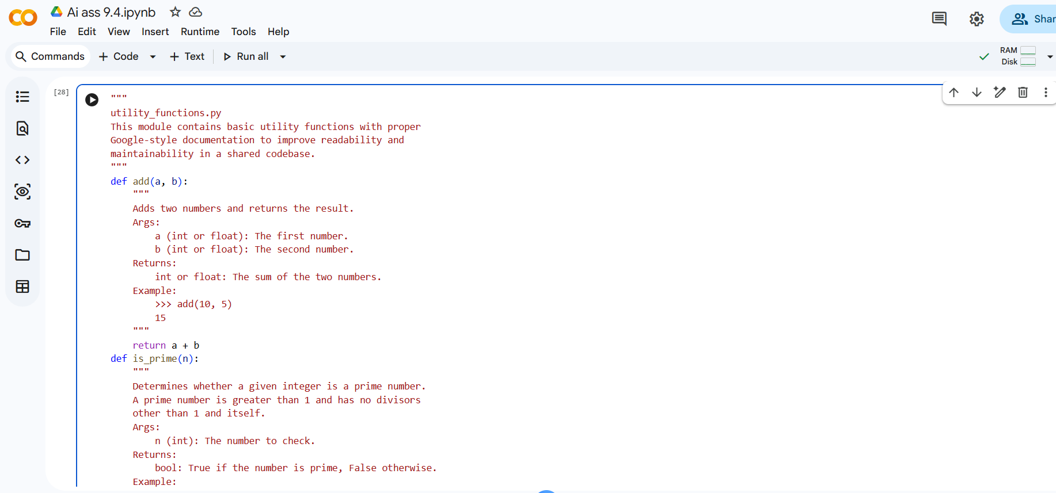
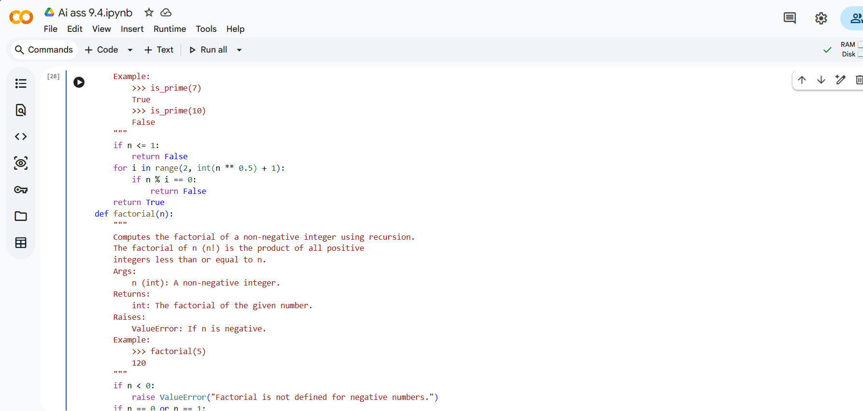

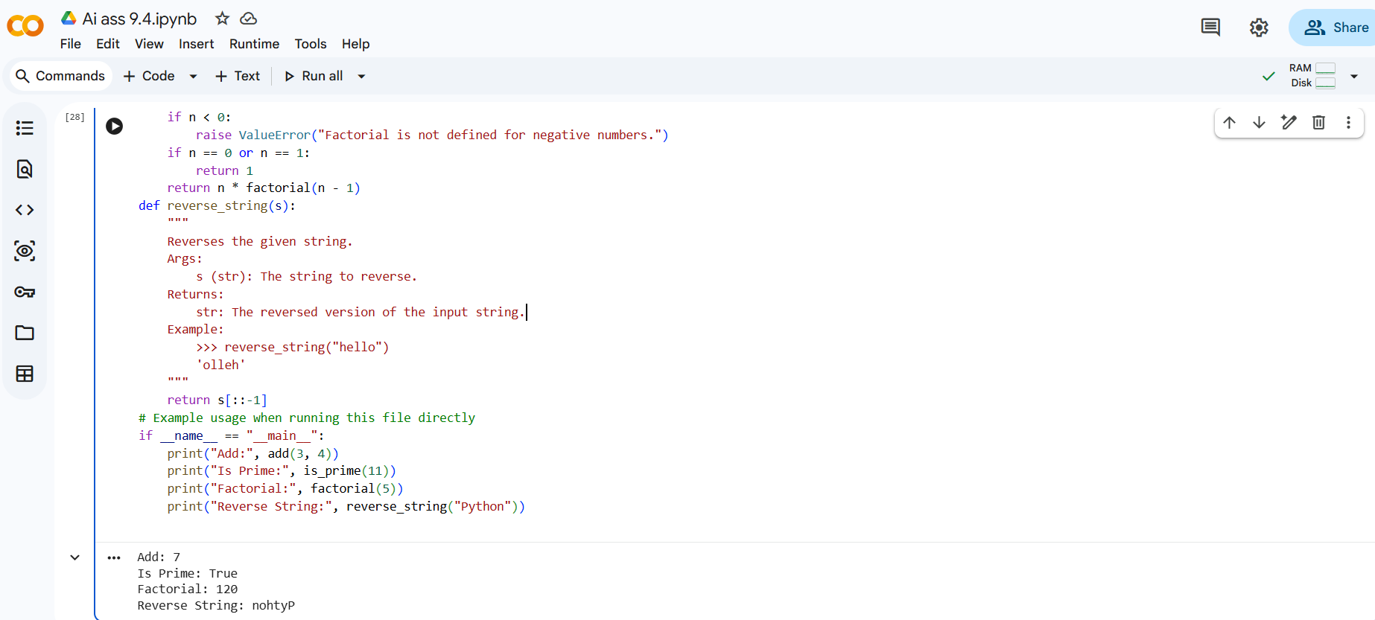

Task2
You are a senior Python developer reviewing a codebase for readability improvements.
The following Python script contains complex logic, including loops, conditional statements, and algorithms. The code works correctly but lacks clarity.

Your task:
- Insert concise inline comments ONLY where the logic is complex or non-obvious.
- Explain WHY the logic exists, not what basic Python syntax does.
- Avoid commenting on trivial or self-explanatory lines.
- Do not modify the original logic or structure.
- Keep comments professional and minimal to avoid clutter.
Return the improved version of the script with meaningful inline comments added.
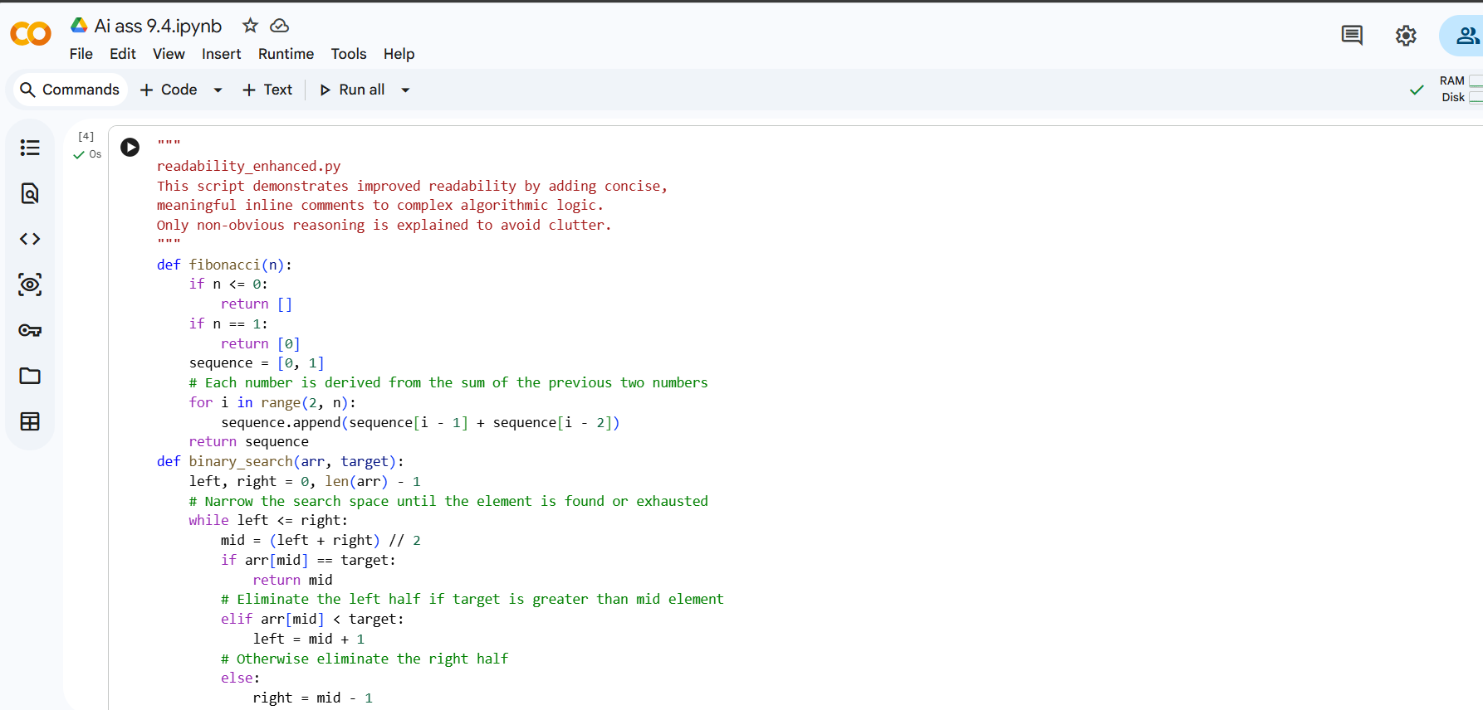

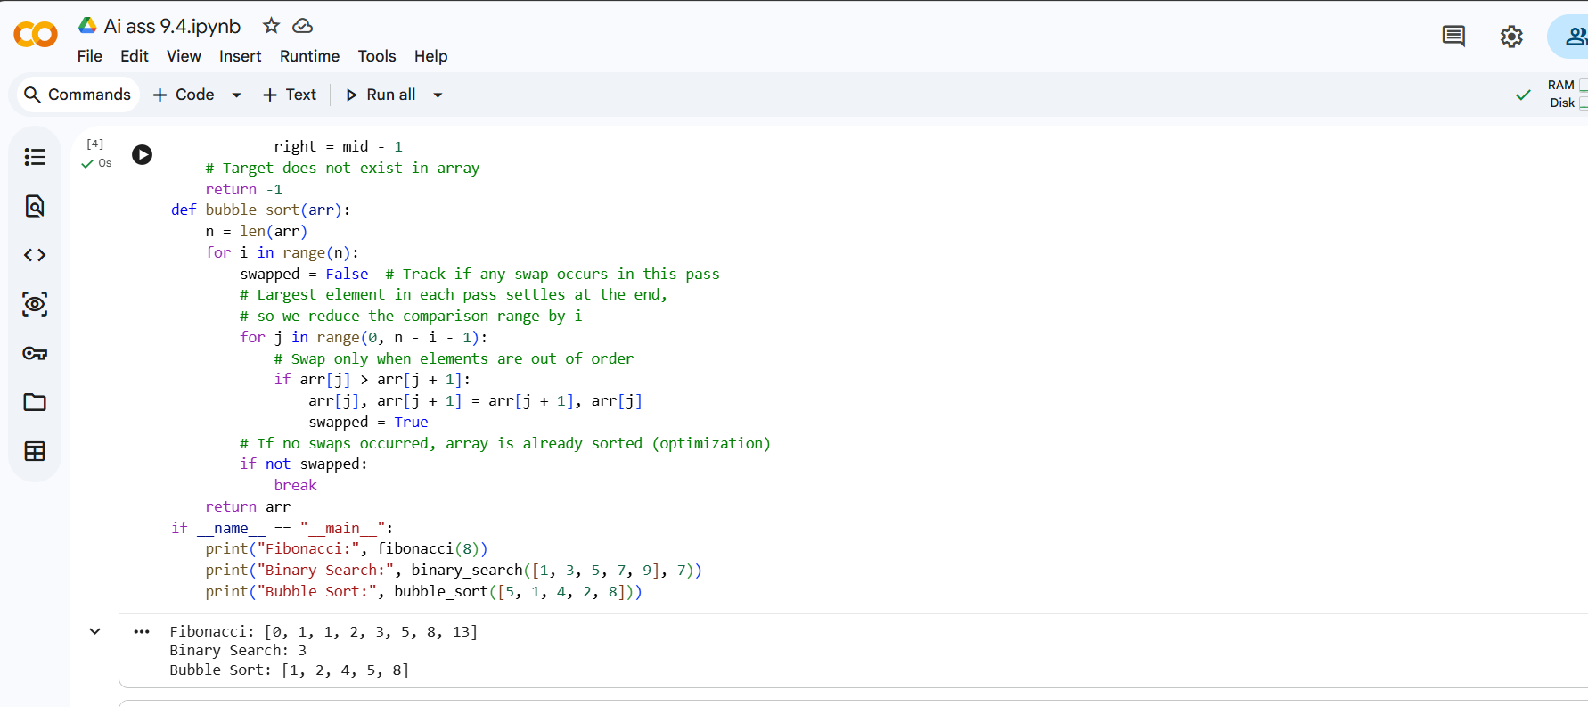
Task 3
You are a Python documentation expert preparing a module for internal or public use.
Analyze the following complete Python module and generate a professional multi-line module-level docstring to be placed at the top of the file.
The docstring must include:
- A clear explanation of the module's purpose
- Required libraries or dependencies
- A brief description of key functions and classes
- A short example demonstrating how to use the module
- Professional tone suitable for production code
Do not modify the existing code.
Only generate the module-level docstring.

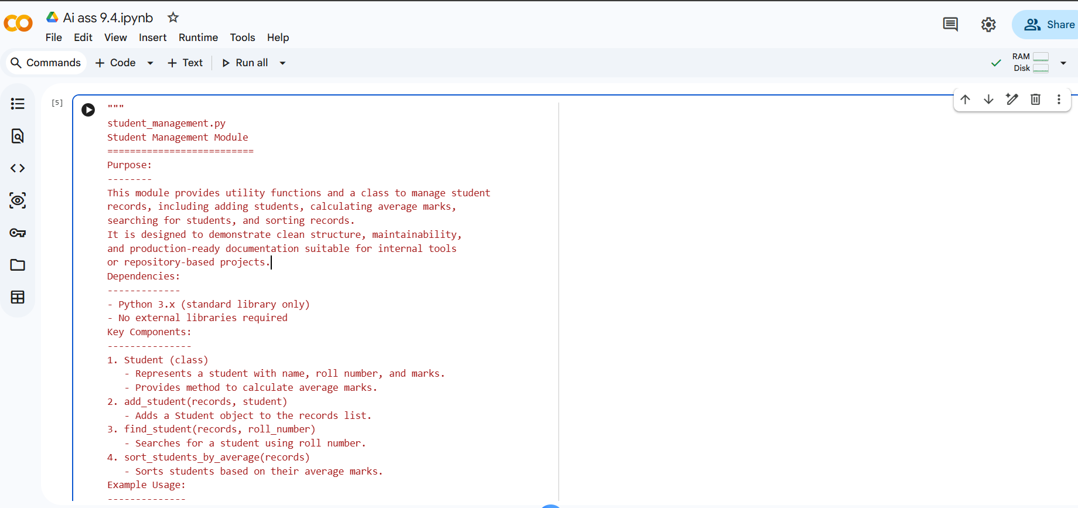

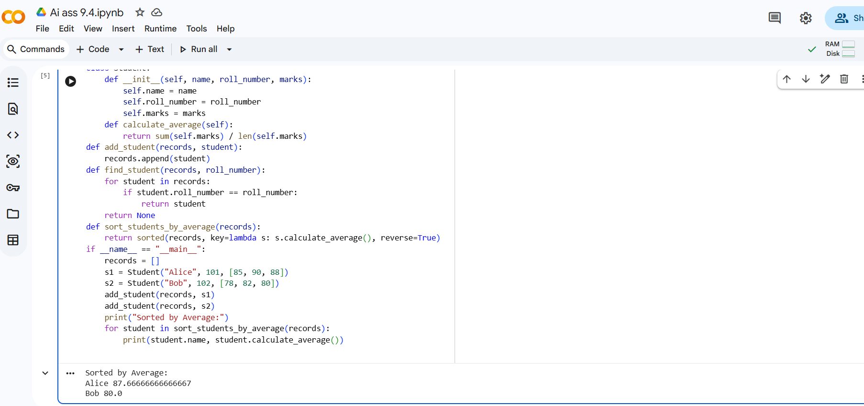

Task 4
You are a Python refactoring specialist helping standardize documentation in a legacy project.
The following script contains detailed inline comments inside functions explaining their behavior. These should be converted into structured docstrings.
Your task:
- Convert relevant explanatory comments into proper Google-style (or NumPy-style) docstrings.
- Preserve the original meaning and intent.
- Include:
- Description
- Parameters with types
- Return values with types
- Remove redundant inline comments after conversion.
- Do not modify function logic.
Return the cleaned and standardized version of the script.
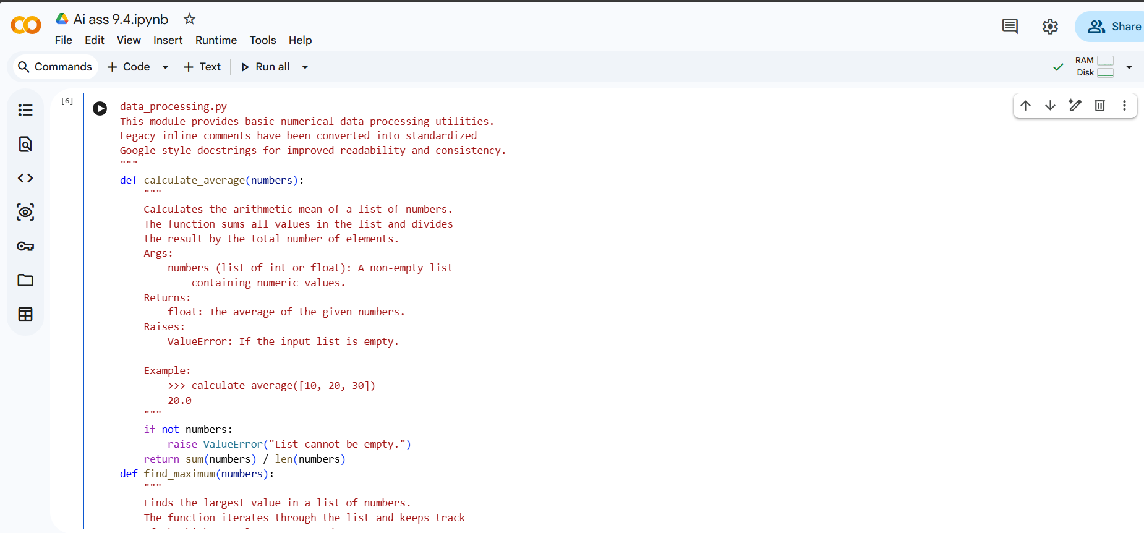

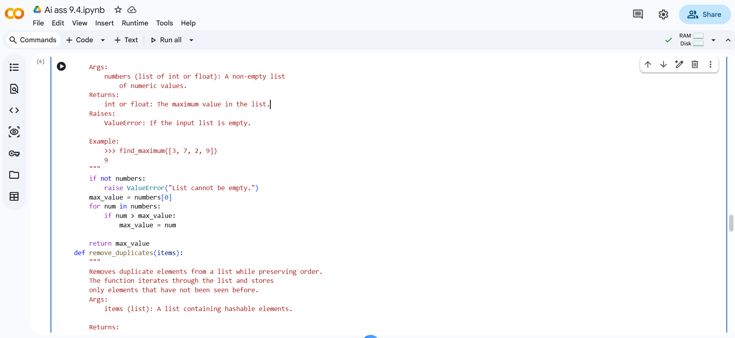

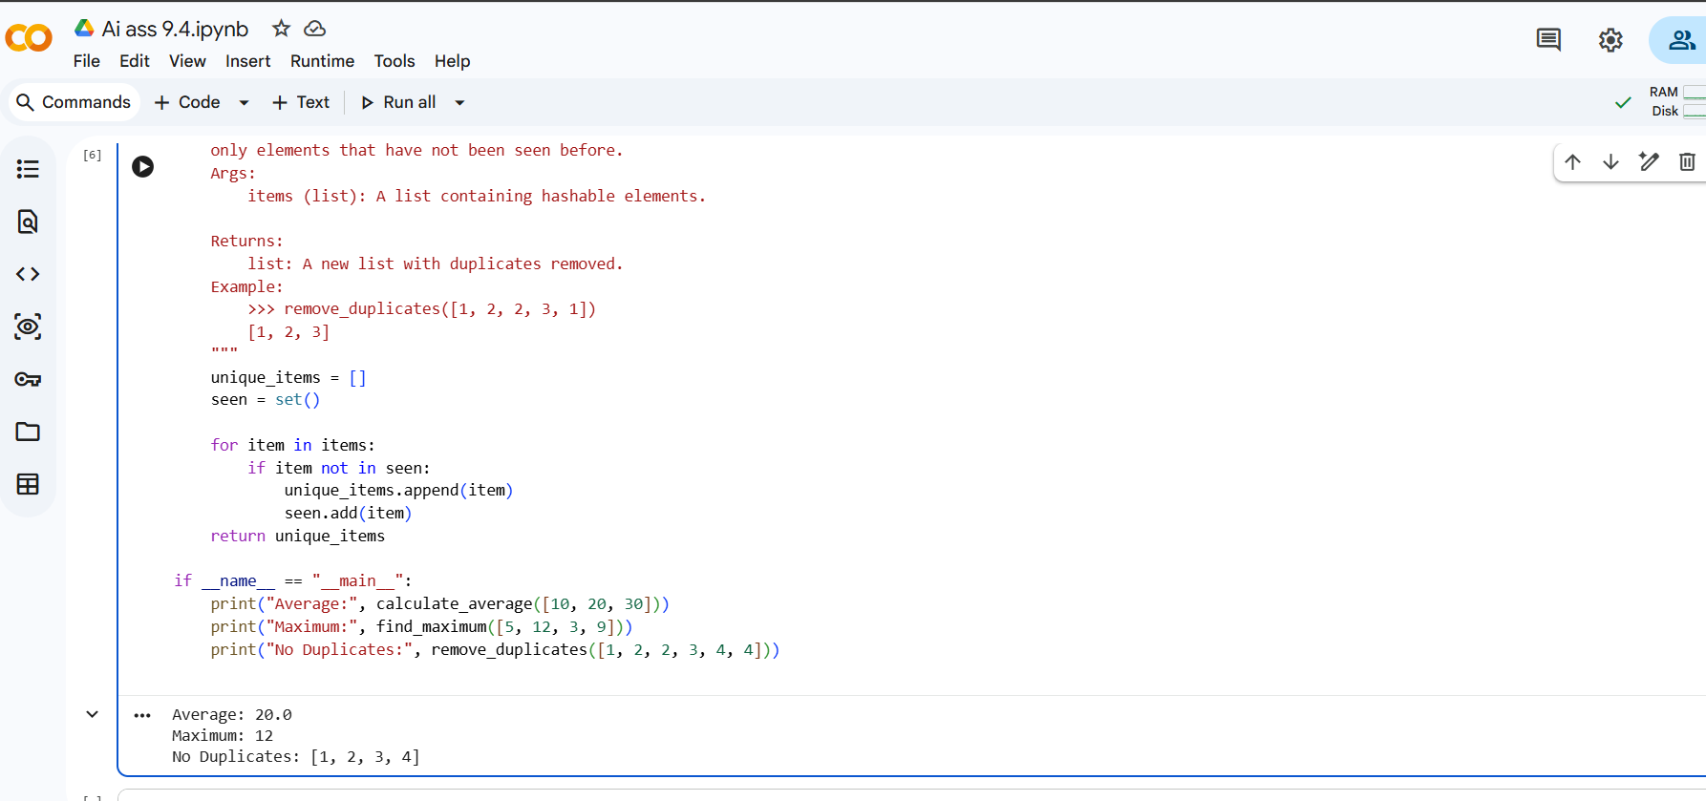
Task 5
You are a Python developer building an internal documentation scaffolding tool.Design a small Python utility that:
- Reads a given .py file
- Automatically detects all functions and classes
- Inserts placeholder Google-style docstrings if none exist
- Preserves indentation and formatting
- Does not modify existing docstrings
The generated placeholder docstrings should include:
- Short description placeholder - Args section
- Returns section (if applicable)
The goal is documentation scaffolding, not perfect documentation.
Provide:
1. A complete working Python script
2. Clear explanation of how it works
3. Example of how to run it
Ensure the solution is clean, readable, and suitable for internal tooling.
